ODSQL & API v2.1 Tutorial 2024
This document explains how to use the API of City of Melbourne Open Data (CoM). Only the HTTP (GET) method is supported, all API endpoints return JSON. Endpoints use ODSQL.
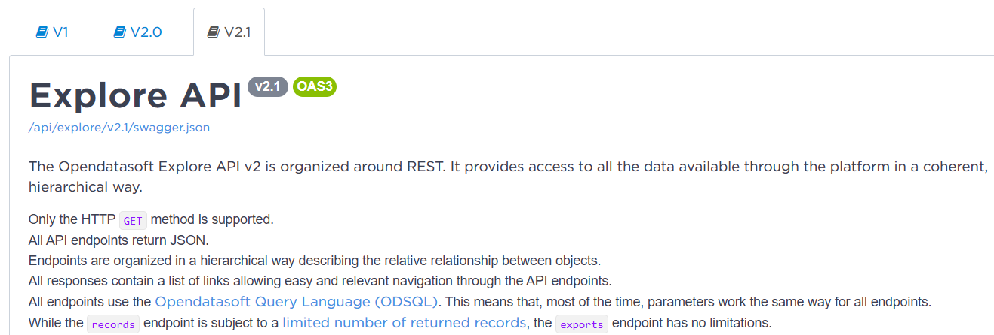

Note
- These instructions only apply to API v2.1 and the City of Melbourne Open Data.
- `records` endpoint is subject to a limited number of returned records
- `exports` endpoints has no limitations!
- Each organization's API settings are different!
Some parts of the documentation, such as loop acquisition. The government may ban it in subsequent updates, and it does not apply to team' API keys with advanced permissions. For commercial enterprises, loop acquisition is likely to be disabled and may be defaulted by the system as an attack or illegal request.

Explore Datasets
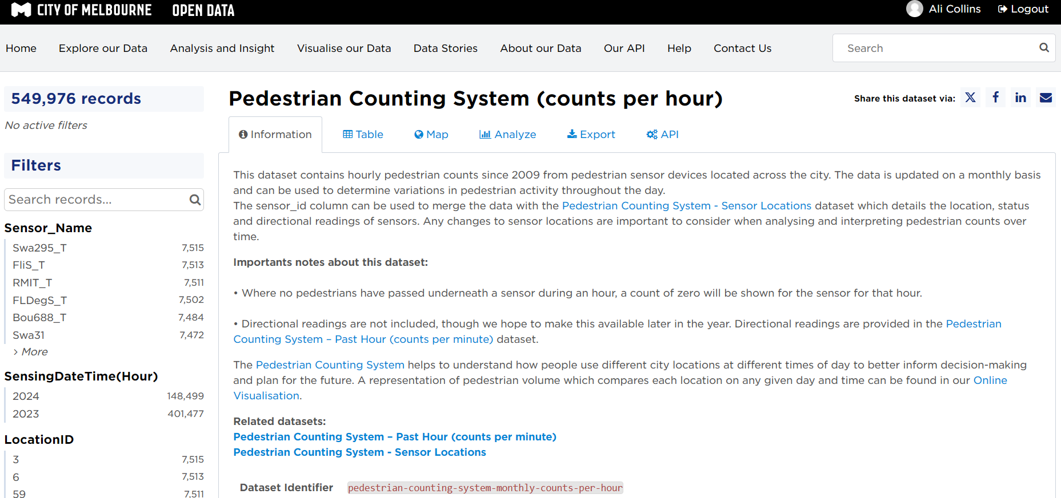
Dataset Pedestrian Counting System (counts per hour)

Appy for Personal API Key
Do not share your API key, keep it secret.
Instructions on applying for a API key

API Keys
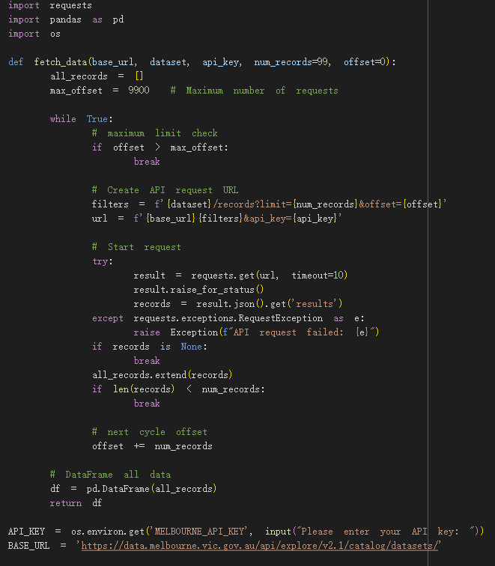
DO NOT EXPOSE YOUR API KEY – IT IS A SECURITY RISK!

Option 1. Remove API KEY Before Publishing (leave as empty string)
Risky you could forget!
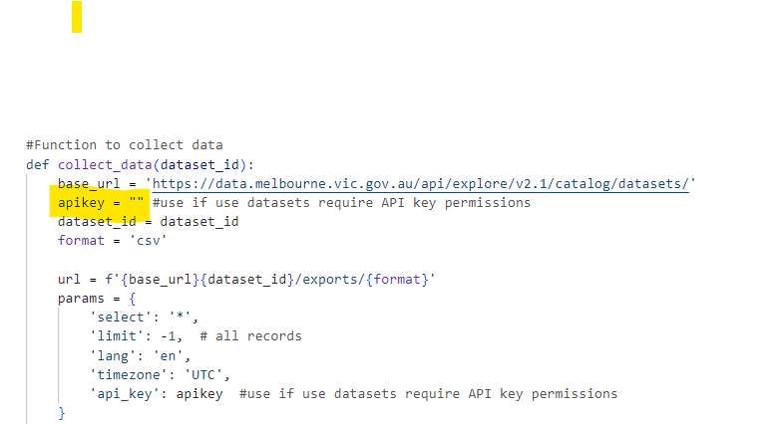

Option 2. Pull API key from Separate File (Locally or GitHub)
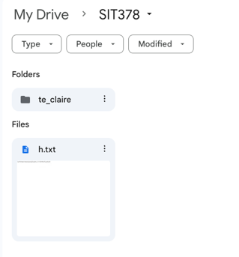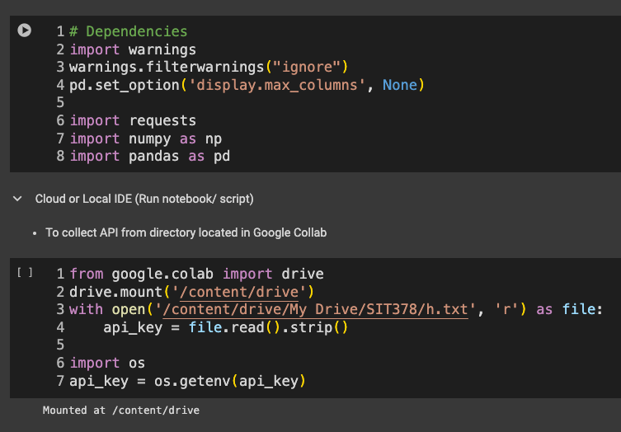
Load Dependencies and load Cloud (Google Collab)

Option 3. Using Google Cloud Secret Manager
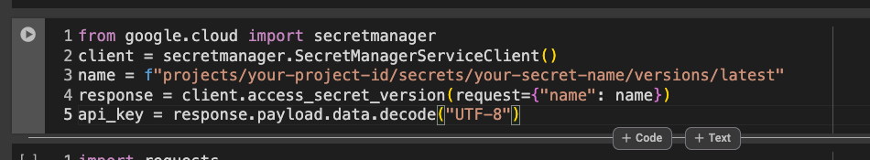

Pre-fill parameters (Optional: filtering)
Opendatasoft Query Language (ODSQL) allows you to filter datasets or records and build aggregations.
https://help.opendatasoft.com/apis/ods-explore-v2/#section/Opendatasoft-Query-Language-(ODSQL)
Using the Console you can prefill your parameters and create a GET curl request, you can then use Python HTTP Request (Import requests) library to call API by interacting via HTTP methods.
https://data.melbourne.vic.gov.au/api/explore/v2.1/console

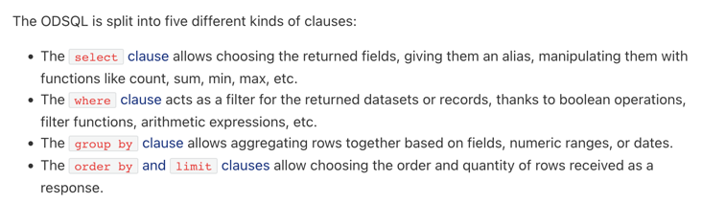
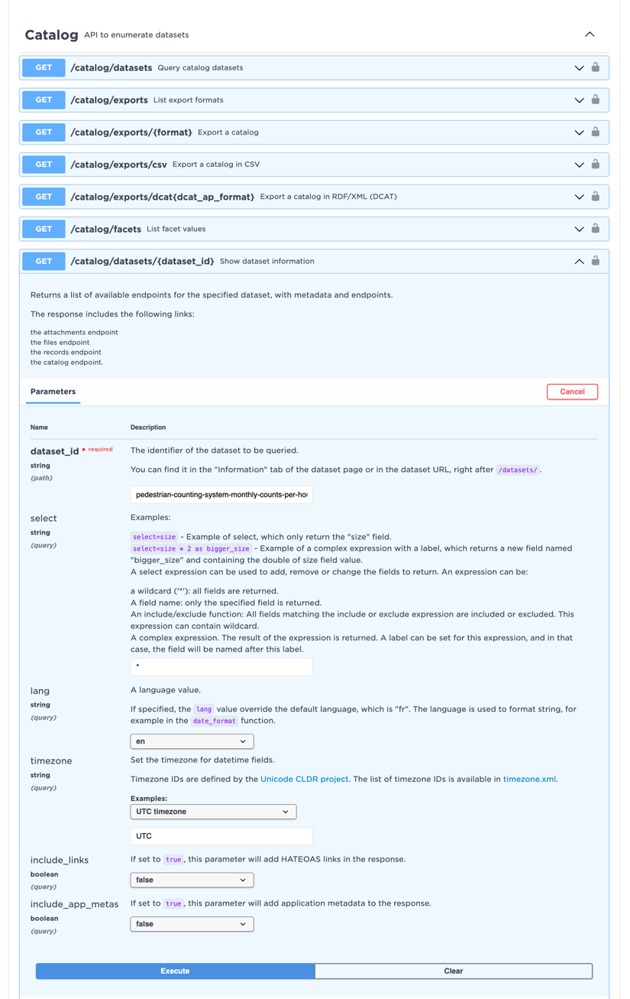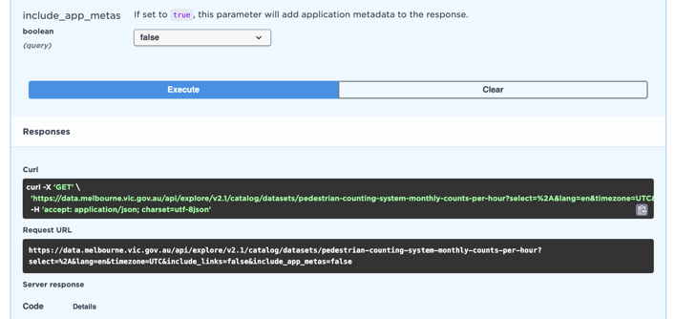

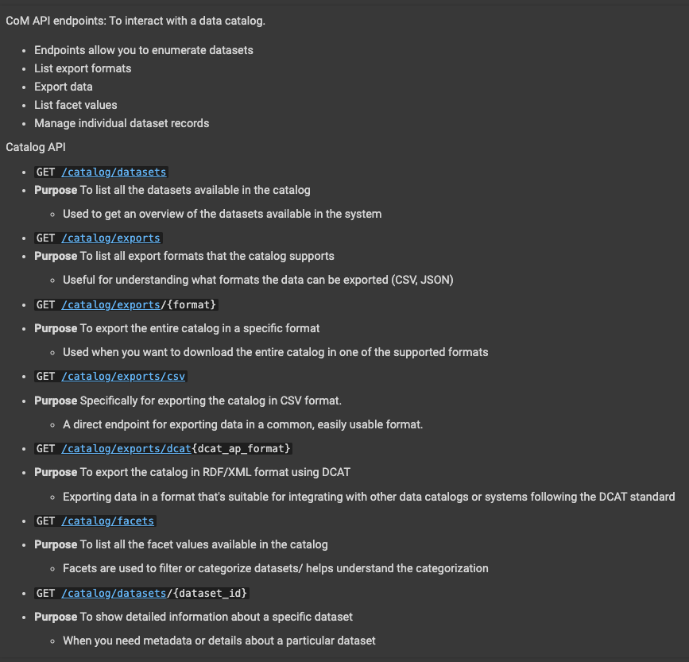
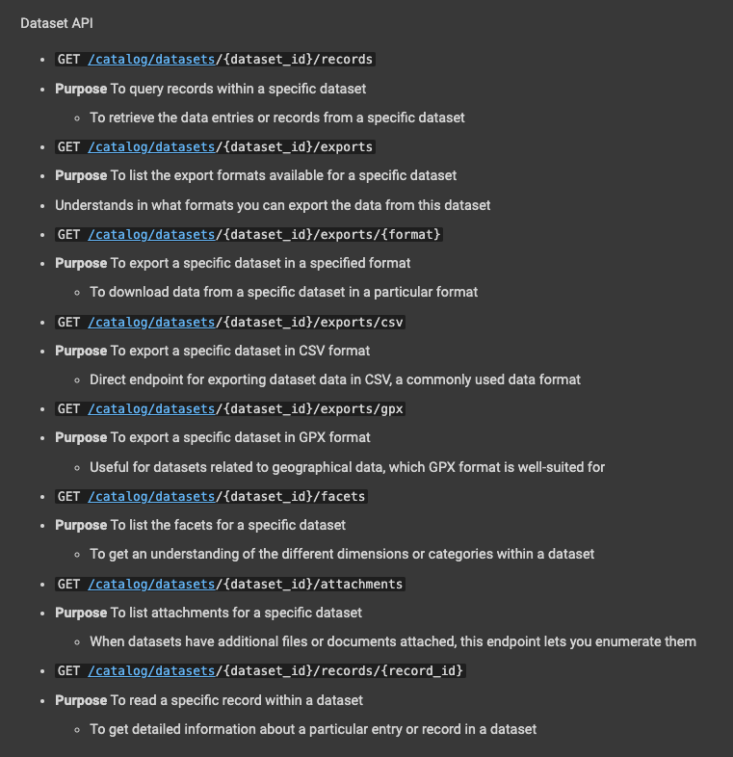

1. exports API (Endpoint)
*Preferred method by CoM as it has no limitations

Example: Single Request for CSV file
GET/Catalog/exports

`GET https://data.melbourne.vic.gov.au/api/catalog/datasets/pedestrian-counting-system-monthly-counts-per-hour`

This can take a little while as you are pulling the whole dataset
Feel free to add a progress bar etc

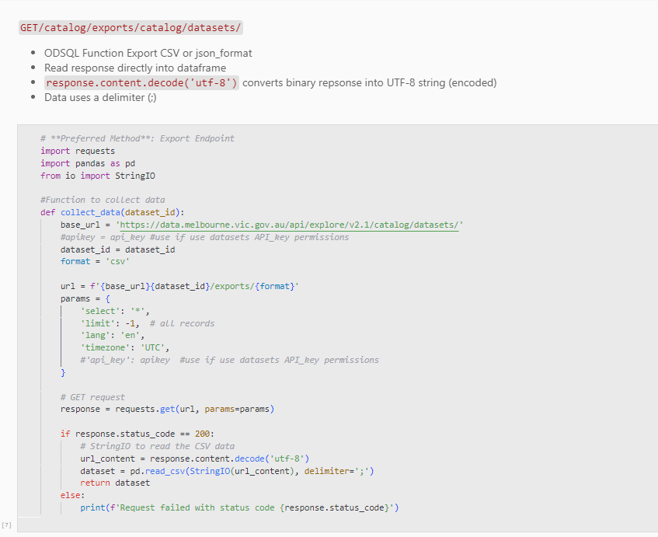
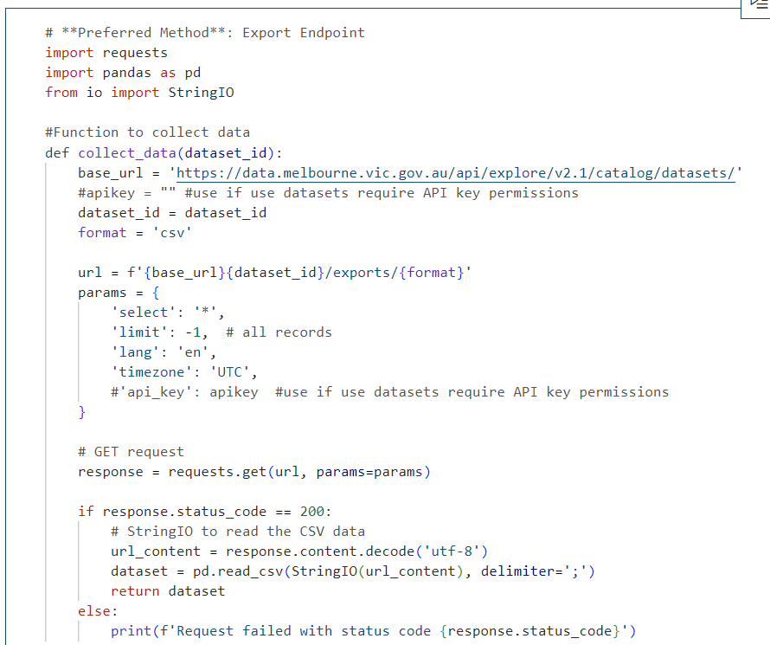
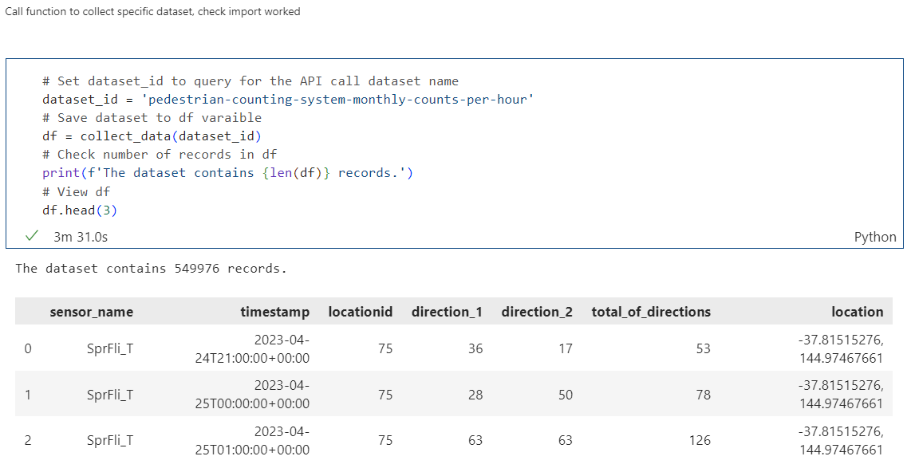

Additional examples exports endpoint
Catalog (API to enumerate datasets) or Dataset (API to work on records)

Example: Catalog API to enumerate datasets
GET/Catalog/datasets

`GET https://data.melbourne.vic.gov.au/api/catalog/datasets`
Limit 10, this can be commented out
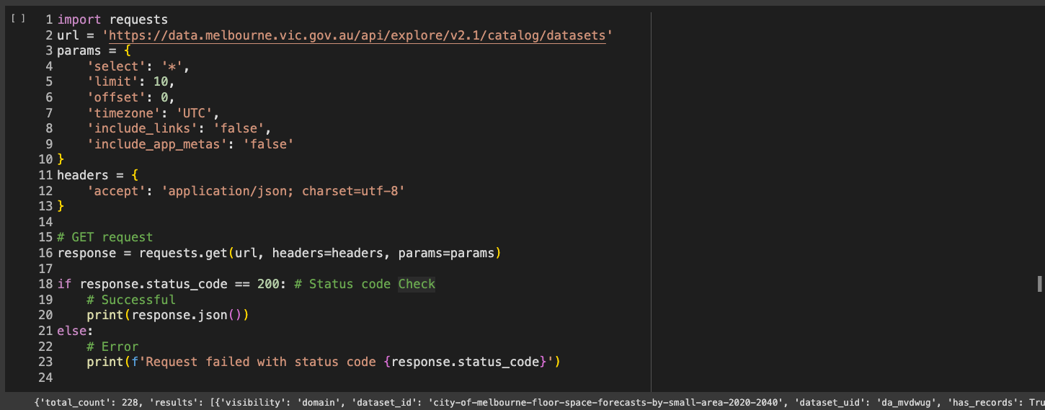

Example: Show dataset Information
GET/Catalog/datasets/{dataset_id}

`GET https://data.melbourne.vic.gov.au/api/catalog/datasets/pedestrian-counting-system-monthly-counts-per-hour`
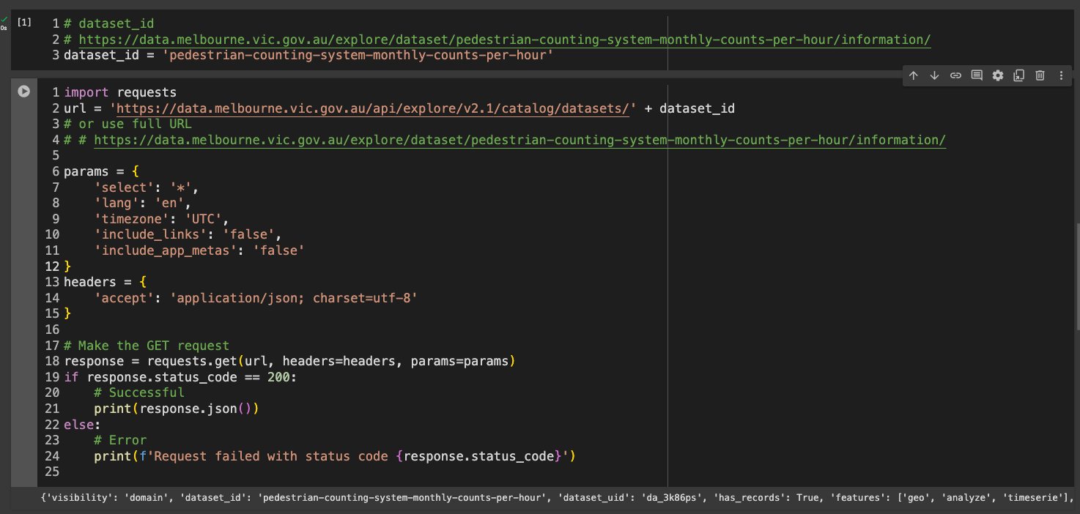
Limit parameter controls the number of records or datasets returned in the response.

Example: Check Available export formats for dataset
GET/Catalog/exports `
GET https://data.melbourne.vic.gov.au/api/catalog/datasets/pedestrian-counting-system-monthly-counts-per-hour`

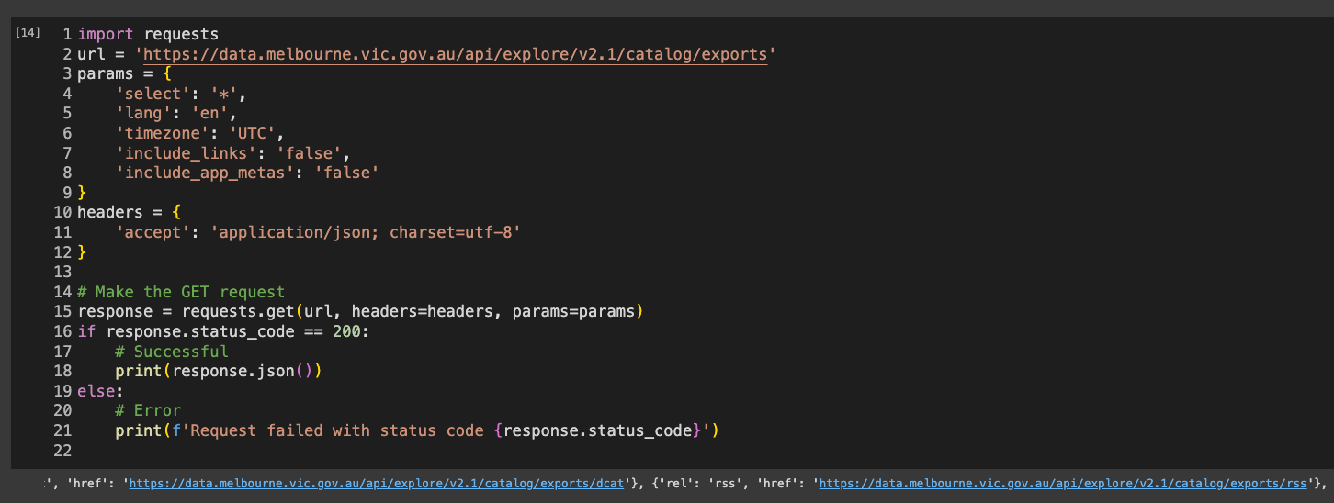

2. records API (Endpoint)
*Not preferred by CoM as it has limitations < 10000 records

Example: Function to iterate over data chunks using API until max offset reached
{dataset}/records?limit={num_records}&offset={offset}
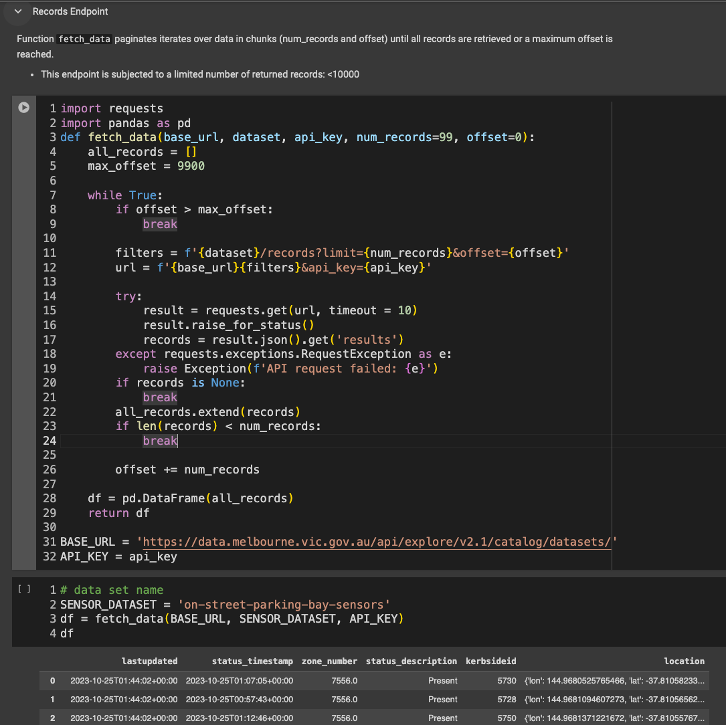

Author
Te’ Claire 2024.v1
Alison Collins 2024.v2

